#### Macintosh HD:Users:Helena:Desktop:Screen Shot 2017-02-22 at 17.29.30.png

**PRIZES**

Each student who submits an entry will receive a certificate.

The best entries will be displayed on the Department of Physics Primary Outreach website.

The winners of each category and their teachers and families will be invited to the Department of Physics garden party on Sunday ----- at the University of Oxford to receive a special prize and a professionally printed A1 version of their poster.

**THINGS TO INCLUDE**

Your webpage poster MUST include information about the following:

* What is gravity?
* What are its effects?
* How does it act on objects around us?

You should also include some more information, for example:

* Newton’s investigations into gravity
* Galileo’s famous experiment about gravitational acceleration
* How does gravity differ on different planets and in space?
* How can we overcome gravity to launch objects into space?
* What is gravity like for astronauts on a space station or on a space walk?

You do not need to include information about all these points, they are just some suggestions to get you thinking – you might even come up with something better yourself!

**FORMAT OF ENTRIES**

Your entry should be A3 in size and can be made by hand or on a computer, but it MUST be submitted electronically in PDF format. Make sure you don’t forget the content mentioned previously that must be included!

You need to make sure that your poster contains good scientific information, but remember that it is in the style of a webpage to be read by students of your own age and younger, so your poster should also be lively and eye-catching, using colour and pictures/diagrams. Your poster will be judged on both these aspects!

You can use any type of resource to help you with your poster, including textbooks, libraries and the Internet, but please note that not all information online has been checked for accuracy, so make sure any websites you use look to be trustworthy, correct and of a high standard (e.g. the NASA website). Direct copying will be marked down, so make sure to write everything in your own words!

**RULES**

1. The posters must be **A3** in size
2. You should use textbooks, libraries and the Internet to search for material to include (but make sure any websites you use are accurate sources!)
3. You can enter individually, or through your school (schools are asked to submit their best entries only – please no more than 4 per class)
4. Make sure your **name** is at the top of your poster
5. Entries must arrive by **28th May 2019**
6. Entries should be submitted electronically in **PDF form** and emailed to: schools.liason@physics.ox.ac.uk
7. Winners will be notified by **5th June 2019**

This competition is open to students in **years 4-7** and will be judged in two categories:

* Years 4 & 5
* Years 6 & 7

**The Department of Physics invites YOU to help us create a new Primary school Physics webpage! YOUR TASK is to design a poster in the style of an educational webpage aimed at Primary school students explaining the force of gravity and how it has been scientifically investigated.**

# **Poster Competition: The Force of Gravity!**

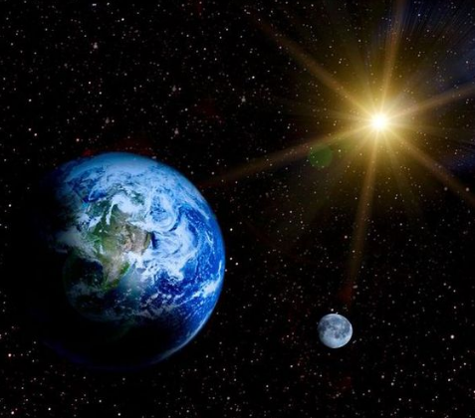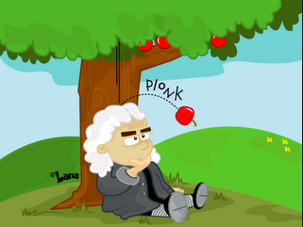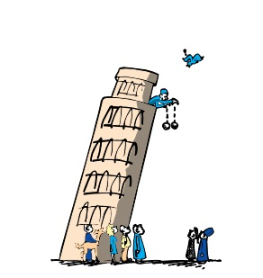

**Entry Form**

Please fill out this form and return this electronically, along with a PDF of your poster to: schools.liason@physics.ox.ac.uk

Pupil name: _____________________________________________________________________

School name: _____________________________________________________________________

School address: _____________________________________________________________________

_____________________________________________________________________

_____________________________________________________________________

Name of teacher: _____________________________________________________________________

Contact phone*: _____________________________________________________________________

Teacher/parent/guardian’s email: ________________________________________________________

Age: _____________ Year group category (please circle): Y4 & Y5 Y6 & Y7

**I confirm that the material submitted is the student’s own work**

**Signature of teacher/parent/ ………………………………………………………………………………………………………**

*This can be either your parent, or your teacher, or left blank as long as we have an email address to contact you with!