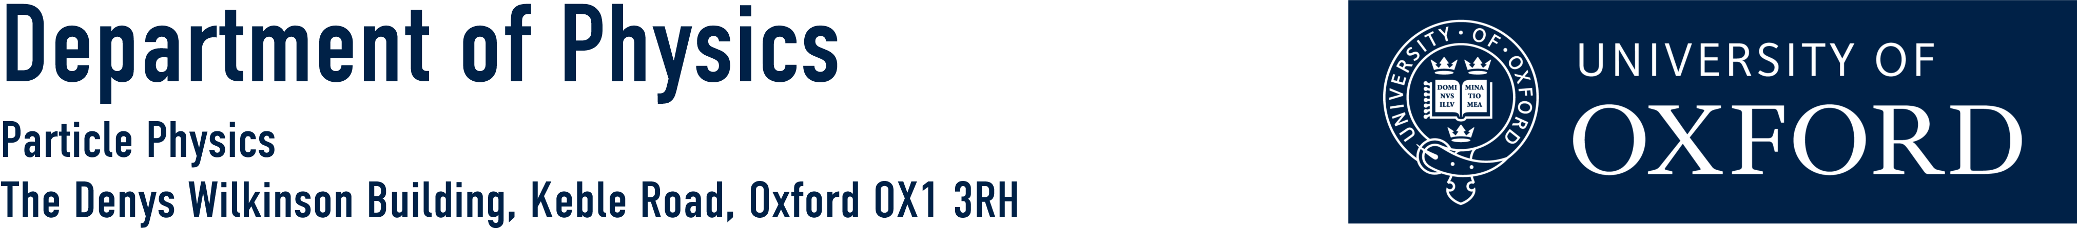

Talk for Prospective DPhil Students

Wednesday 30th November 2016

3:30 pm – talks
5:00 pm – drinks reception

The talks will be given by:

Professor Daniela Bortoletto
Director of Graduate Studies for Particle Physics

Professor Subir Sarkar
Head, Particle Theory Group

Professor Andrei Seryi
John Adams Institute for Accelerator Science

The talks will take place in the:

Dennis Sciama Lecture Theatre
Denys Wilkinson Building, Keble Road, Oxford

If you have any questions then please contact:

Kim Proudfoot 01865 273360 kim.proudfoot@physics.ox.ac.uk

http://www2.physics.ox.ac.uk/study-here/postgraduates/particle-physics

