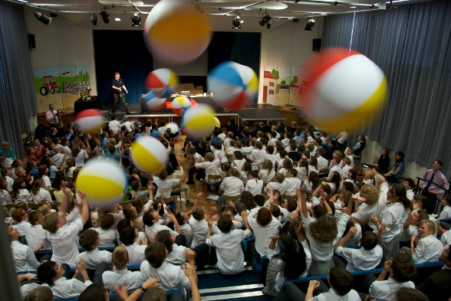
Accelerate!
Saturday 23rd June 2012
Martin Wood Lecture Theatre,
Department of Physics, University of Oxford, Parks Road, OX1 3PU
3.00pm – 4.00pm
Accelerate! is a science show, allowing you to get up close and personal with the exciting world of particle and accelerator physics.
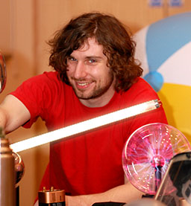
You’ll learn how particle accelerators can do everything from recreating the conditions just after the Big Bang to creating new ways to treat cancer. You will also find out about the World's biggest machine; the Large Hadron Collider in Switzerland.
Explosions, hair-raising experiences and objects which float in mid-air are just some of the things you’ll see in the Accelerate! show. It’s all in the name of science and, best of all, it’s FREE!
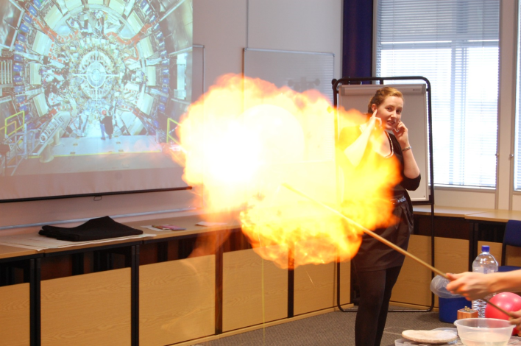
Join scientists from the University of Oxford taking you on a guided tour of the science behind atom smashers. Enjoy exciting demonstrations with plenty of audience involvement; all whilst learning about some of the most exciting science of our time!
To book contact: Lena Shams
E: schools.liaison@physics.ox.ac.uk T: 01865 272884

