Family photo of Topological Weyl Semimetals
Different branches of science typically deal with very different concepts and research subjects that seldom overlap. Though once in a while, a common idea can emerge, propagate across different fields, and lead to rare discoveries appreciated by scientists in all fields, showing the generality, profoundness, and beauty of science.
Recently, a new state of quantum matter – the 3D topological Weyl semimetal (TWS) was proposed to exist in solid. This type of materials can be viewed as the hybrid of “3D graphene” and topological insulators: On one hand, a TWS possesses bulk Weyl fermions (a concept originally proposed in high energy physics) which are intriguing chiral particles embracing linear band dispersion along all three momentum directions through the Weyl points (which can be viewed as magnetic monopoles in the momentum space). On the other hand, a TWS also possesses non-trivial topological surface states that form exotic “Fermi-arcs”– unusual Fermi-surfaces consisting of unclosed curves (unlike the closed Fermi surface pockets in conventional materials) that start from and end at Weyl points of different chirality.
These unusual bulk and surface electronic structures of 3D TWSs can give rise to many exotic phenomena, such as chiral magnetic effects, negative magnetoresistance, quantum anomalous Hall effect, novel quantum oscillations in magneto-transport and quantum interference in tunneling spectroscopy. In addition, appealing transport properties have also been discovered in some 3D TWS candidates, such as the ultra-high carrier mobility (e.g. 5×10⁶ cm²V⁻¹s⁻¹ in NbP) and extremely large magnetoresistance (e.g. 850,000% in NbP), making 3D TWSs not only ideal for fundamental research, but also promising materials for novel applications.
To search for TWSs, the most direct way is to look for their unique electronic structures that contains the characteristic “Fermi-arcs” – which is topologically distinct from the Fermi-surfaces of conventional materials whose Fermi-surfaces have to be closed pockets. Recently, an international team of scientists lead by Oxford University academic (including ShanghaiTech and Tsinghua University in China and Max Planck Institute in Dresden) have successfully discovered made the “family photo” of a serious TWS compounds. [1].
In a work just published in Nature Materials online on Monday (http://dx.doi.org/10.1038/nmat4457), electronic structures of three TWSs (NbP, TaP and TaAs) in a transition metal monopnictide family are reported. The international team of scientists carried out comprehensive study on these exotic materials using both angle resolve photoemission spectroscopy (ARPES) and ab initio calculations, and clearly identified the characteristic surface “Fermi-arcs” in all three compounds as well as the evolution of their electronic structures, thus making a “family photo” of this family of excitingly unusual materials. Furthermore, they also illustrates that spin-orbit couple (SOC) can be a “knob” to fine-tune and control the properties of TWS materials.
The discovery of this family of TWS compounds not only provides a rich material base for exploring unusual physical phenomena (e.g. chiral magnetic effects, negative magnetoresistance, and quantum anomalous Hall effect) but also opens the door for novel future applications due to their exotic but appealing physical properties.
[1] Z. K. Liu, L. X. Yang, Y. Sun, T. Zhang, H. Peng, H. F. Yang, C. Chen. Y. Zhang, Y. F. Guo, D. Prabhakaran, M. Schmidt, Z. Hussain, S.-K. Mo, C. Felser, B. Yan and Y. L. Chen, “Evolution of the Fermi surface of Weyl semimetals in the transition metal pnictide family” Nature Materials, Online advanced publication, http://dx.doi.org/10.1038/nmat4457

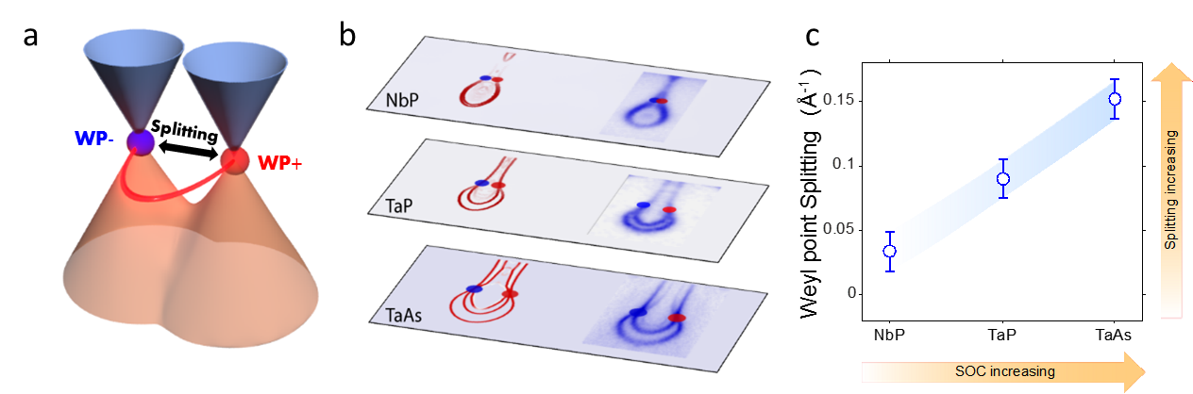
Family photo of Weyl semimetals： (a) Illustration of bulk Weyl fermions and points. Red and blue colors indicating the different chirality of Weyl points (W+ and W-) which are connected by the exotic surface Fermi-arc (red curve). (b) Theoretical calculation and experimental observation of the evolution of Weyl points and surface Fermi-arcs in three compounds of the family. (c) The separation of the Weyl points increase with the spin-orbit coupling of different compounds.

