Atomic and Laser Physics Seminar
Monday, 5 November
11.30
Audrey Wood Seminar Room

Dr David Allcock
Department of Physics

Microwave driven quantum logic gates
in 43Ca+
We present a novel qubit in the ground state of ⁴³Ca⁺ at intermediate magnetic field (146 G). This qubit is magnetic field insensitive to first order and has a coherence time of tens of seconds. Using robust optical pumping and microwave techniques we demonstrate single qubit gates with errors at the 10⁻⁶ level and a combined preparation and readout error below 10⁻³. These fidelities are low enough for fault-tolerant quantum computing and set new benchmarks for any experimentally realised qubit.
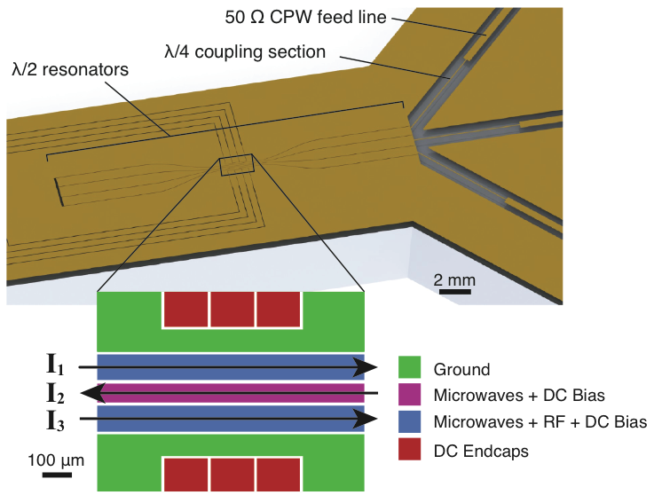
Figure 1: Surface-electrode ion trap with integrated microwave resonators and coupling elements.
This work was carried out in an ion trap which incorporates three half-wave microwave resonators (see fig. 1). These resonators are optimised to give high microwave field gradients at the ion in order to produce state dependent forces. The next goal is to carry out microwave-driven two qubit gates [1] in this trap and the latest progress towards this will be reported. [1] C Ospelkaus et al. Nature 476, 181 (2011)

