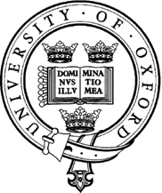
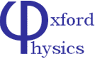

Talk for Prospective DPhil Students

Monday 1st December 2014
4:00p.m – talks
5:30p.m – drinks reception

The talks will be given by
Professor Amanda Cooper-Sarkar
Director of Graduate Studies for Particle Physics

Professor Subir Sarkar
Activity in Particle Theory

Professor Andrei Seryi
John Adams Institute for Accelerator Science

The talks will take place in the
Dennis Sciama Lecture Theatre,
Denys Wilkinson Building, Keble Road, Oxford

If you have any questions then please contact

Kim Proudfoot 01865 273360 k.proudfoot@physics.ox.ac.uk

http://www2.physics.ox.ac.uk/study-here/postgraduates/particle-physics

